**BANK LOAN REPORT QUERY DOCUMENT**

1. **BANK LOAN REPORT | SUMMARY**

**KPI’s:**

**Total Loan Applications**

select count(id) as Total\_Loan\_Applications from Bank\_Loan\_DB;

C:\Users\Lenovo\AppData\Local\Packages\Microsoft.Windows.Photos_8wekyb3d8bbwe\TempState\ShareServiceTempFolder\Screenshot 2023-12-09 120703.jpeg

**Month to Date Total Loan Applications**

select count(id) as MTD\_Total\_Loan\_Applications from Bank\_Loan\_DB

where Month(issue\_date)=(select MAX(Month(issue\_date)) from Bank\_Loan\_DB)

and Year(issue\_date)=(select max(Year(issue\_date))from Bank\_Loan\_DB);

C:\Users\Lenovo\AppData\Local\Packages\Microsoft.Windows.Photos_8wekyb3d8bbwe\TempState\ShareServiceTempFolder\Screenshot 2023-12-09 134458.jpeg

**Month over Month Total Loan Applications**

select count(id) as PMTD\_Total\_Loan\_Applications from Bank\_Loan\_DB

where Month(issue\_date)=(select (MAX(Month(issue\_date)-1)) from Bank\_Loan\_DB)

and Year(issue\_date)=(select (max(Year(issue\_date)))from Bank\_Loan\_DB);

C:\Users\Lenovo\AppData\Local\Packages\Microsoft.Windows.Photos_8wekyb3d8bbwe\TempState\ShareServiceTempFolder\Screenshot 2023-12-09 134539.jpeg

**Total Funded Amount**

select sum(loan\_amount) as Total\_Funded\_Amount from Bank\_Loan\_DB;

C:\Users\Lenovo\AppData\Local\Packages\Microsoft.Windows.Photos_8wekyb3d8bbwe\TempState\ShareServiceTempFolder\Screenshot 2023-12-09 134929.jpeg

**Month to Date Total Funded Amount**

select sum(loan\_amount) as MTD\_Total\_Funded\_Amount from Bank\_Loan\_DB

where MONTH(issue\_date)=(select max(month(issue\_date)) from Bank\_Loan\_DB)

and Year(issue\_date)=(select max(year(issue\_date)) from Bank\_Loan\_DB);

C:\Users\Lenovo\AppData\Local\Packages\Microsoft.Windows.Photos_8wekyb3d8bbwe\TempState\ShareServiceTempFolder\Screenshot 2023-12-09 135014.jpeg

**Month over Month Total Funded Amount**

select sum(loan\_amount) as PMTD\_Total\_Funded\_Amount from Bank\_Loan\_DB

where MONTH(issue\_date)=(select (max(month(issue\_date)-1)) from Bank\_Loan\_DB)

and Year(issue\_date)=(select max(year(issue\_date)) from Bank\_Loan\_DB);

C:\Users\Lenovo\AppData\Local\Packages\Microsoft.Windows.Photos_8wekyb3d8bbwe\TempState\ShareServiceTempFolder\Screenshot 2023-12-09 135037.jpeg

**Total Amount Received**

select sum(total\_payment) as Toatl\_Amount\_Received from Bank\_Loan\_DB;

C:\Users\Lenovo\AppData\Local\Packages\Microsoft.Windows.Photos_8wekyb3d8bbwe\TempState\ShareServiceTempFolder\Screenshot 2023-12-09 135429.jpeg

**Month to Date Total Amount Received**

select sum(total\_payment) as MTD\_Toatl\_Amount\_Received from Bank\_Loan\_DB

where MONTH(issue\_date)=(select max(month(issue\_date)) from Bank\_Loan\_DB)

and Year(issue\_date)=(select max(year(issue\_date)) from Bank\_Loan\_DB);

C:\Users\Lenovo\AppData\Local\Packages\Microsoft.Windows.Photos_8wekyb3d8bbwe\TempState\ShareServiceTempFolder\Screenshot 2023-12-09 135443.jpeg

**Month over Month Total Amount Received**

select sum(total\_payment) as PMTD\_Toatl\_Amount\_Received from Bank\_Loan\_DB

where MONTH(issue\_date)=(select (max(month(issue\_date)-1)) from Bank\_Loan\_DB)

and Year(issue\_date)=(select max(year(issue\_date)) from Bank\_Loan\_DB);

C:\Users\Lenovo\AppData\Local\Packages\Microsoft.Windows.Photos_8wekyb3d8bbwe\TempState\ShareServiceTempFolder\Screenshot 2023-12-09 135501.jpeg

**Average Interest Rate**

select AVG(int\_rate)\*100 as Average\_Interest\_Rate from Bank\_Loan\_DB;

C:\Users\Lenovo\AppData\Local\Packages\Microsoft.Windows.Photos_8wekyb3d8bbwe\TempState\ShareServiceTempFolder\Screenshot 2023-12-09 140618.jpeg

**Month to Date Average Interest Rate**

select AVG(int\_rate)\*100 as MTD\_Average\_Interest\_Rate from Bank\_Loan\_DB

where MONTH(issue\_date)=(select max(month(issue\_date)) from Bank\_Loan\_DB)

and Year(issue\_date)=(select max(year(issue\_date)) from Bank\_Loan\_DB);

C:\Users\Lenovo\AppData\Local\Packages\Microsoft.Windows.Photos_8wekyb3d8bbwe\TempState\ShareServiceTempFolder\Screenshot 2023-12-09 141219.jpeg

**Month over Month Average Interest Rate**

select AVG(int\_rate)\*100 as PMTD\_Average\_Interest\_Rate from Bank\_Loan\_DB

where MONTH(issue\_date)=(select (max(month(issue\_date)-1)) from Bank\_Loan\_DB)

and Year(issue\_date)=(select max(year(issue\_date)) from Bank\_Loan\_DB);

C:\Users\Lenovo\AppData\Local\Packages\Microsoft.Windows.Photos_8wekyb3d8bbwe\TempState\ShareServiceTempFolder\Screenshot 2023-12-09 140728.jpeg

**Average DTI(Debit to Income) Ratio**

select AVG(dti)\*100 as Average\_DTI from Bank\_Loan\_DB;

C:\Users\Lenovo\AppData\Local\Packages\Microsoft.Windows.Photos_8wekyb3d8bbwe\TempState\ShareServiceTempFolder\Screenshot 2023-12-09 142044.jpeg

**Month to Date Average DTI(Debit to Income) Ratio**

select AVG(dti)\*100 as MTD\_Average\_DTI from Bank\_Loan\_DB

where MONTH(issue\_date)=(select max(month(issue\_date)) from Bank\_Loan\_DB)

and Year(issue\_date)=(select max(year(issue\_date)) from Bank\_Loan\_DB);

C:\Users\Lenovo\AppData\Local\Packages\Microsoft.Windows.Photos_8wekyb3d8bbwe\TempState\ShareServiceTempFolder\Screenshot 2023-12-09 142137.jpeg

**Month over Month Average DTI(Debit to Income) Ratio**

select AVG(dti)\*100 as PMTD\_Average\_DTI from Bank\_Loan\_DB

where MONTH(issue\_date)=(select (max(month(issue\_date))-1) from Bank\_Loan\_DB)

and Year(issue\_date)=(select max(year(issue\_date)) from Bank\_Loan\_DB);

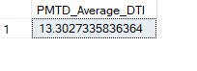

**Good Loan v Bad Loan KPI’s**

**Good Loan KPIs:**

**Good Loan Applications**

select count(id) as Good\_Loan\_Application from Bank\_Loan\_DB

where loan\_status='Fully Paid' or loan\_status='Current';

C:\Users\Lenovo\AppData\Local\Packages\Microsoft.Windows.Photos_8wekyb3d8bbwe\TempState\ShareServiceTempFolder\Screenshot 2023-12-09 152716.jpeg

**Good Loan Applications Percentage**

select

(COUNT(CASE WHEN loan\_status ='Fully Paid' or loan\_status ='Current' THEN id END)\*100) / COUNT (id) AS Good\_Loan\_Percentage from Bank\_Loan\_DB;

C:\Users\Lenovo\AppData\Local\Packages\Microsoft.Windows.Photos_8wekyb3d8bbwe\TempState\ShareServiceTempFolder\Screenshot 2023-12-09 160855.jpeg

**Good Loan Funded Amount**

select sum(loan\_amount) as Good\_Loan\_Funded\_Amount from Bank\_Loan\_DB

where loan\_status='Fully Paid' or loan\_status='Current';

C:\Users\Lenovo\AppData\Local\Packages\Microsoft.Windows.Photos_8wekyb3d8bbwe\TempState\ShareServiceTempFolder\Screenshot 2023-12-09 152739.jpeg

**Good Loan Total Received Amount**

select sum(total\_payment) as Good\_Loan\_Total\_Received\_Amount from Bank\_Loan\_DB

where loan\_status='Fully Paid' or loan\_status='Current';

C:\Users\Lenovo\AppData\Local\Packages\Microsoft.Windows.Photos_8wekyb3d8bbwe\TempState\ShareServiceTempFolder\Screenshot 2023-12-09 152753.jpeg

**Bad Loan Applications**

select count(id) as Bad\_Loan\_Application from Bank\_Loan\_DB

where loan\_status='Charged Off';

C:\Users\Lenovo\AppData\Local\Packages\Microsoft.Windows.Photos_8wekyb3d8bbwe\TempState\ShareServiceTempFolder\Screenshot 2023-12-09 152807.jpeg

**Bad Loan Applications Percentage**

select

(COUNT(CASE WHEN loan\_status ='Charged Off' THEN id END)\*100) / COUNT (id) AS Bad\_Loan\_Percentage from Bank\_Loan\_DB;

C:\Users\Lenovo\AppData\Local\Packages\Microsoft.Windows.Photos_8wekyb3d8bbwe\TempState\ShareServiceTempFolder\Screenshot 2023-12-09 160743.jpeg

**Bad Loan Funded Amount**

select sum(loan\_amount) as Bad\_Loan\_Funded\_Amount from Bank\_Loan\_DB

where loan\_status='Charged Off';

C:\Users\Lenovo\AppData\Local\Packages\Microsoft.Windows.Photos_8wekyb3d8bbwe\TempState\ShareServiceTempFolder\Screenshot 2023-12-09 152824.jpeg

**Bad Loan Total Received Amount**

select sum(total\_payment) as Bad\_Loan\_Total\_Received\_Amount from Bank\_Loan\_DB

where loan\_status='Charged Off';

C:\Users\Lenovo\AppData\Local\Packages\Microsoft.Windows.Photos_8wekyb3d8bbwe\TempState\ShareServiceTempFolder\Screenshot 2023-12-09 152840.jpeg

**Loan Status Grid View**

select loan\_status,count(id) as Total\_Loan\_Applications ,

sum(loan\_amount) as Total\_Loan\_Amount,

sum(total\_payment) as Total\_Received\_Amount,

avg(dti)\*100 as Debit\_to\_Income\_Ratio,

avg(int\_rate)\*100 as Interest\_Rate

from Bank\_Loan\_DB

group by loan\_status;

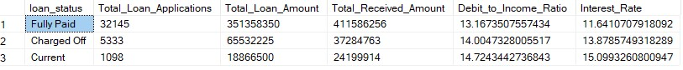

**Month to Date Loan Status Grid View**

select loan\_status,count(id) as Total\_Loan\_Applications ,

sum(loan\_amount) as Total\_Loan\_Amount,

sum(total\_payment) as Total\_Received\_Amount,

avg(dti)\*100 as Debit\_to\_Income\_Ratio,

avg(int\_rate)\*100 as Interest\_Rate

from Bank\_Loan\_DB

where MONTH(issue\_date)=(select Max(month(issue\_date)) from Bank\_Loan\_DB)

and year(issue\_date)=(select Max(year(issue\_date)) from Bank\_Loan\_DB)

group by loan\_status;

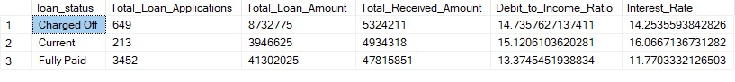**Month over Month Loan Status Grid View**

select loan\_status,count(id) as Total\_Loan\_Applications ,

sum(loan\_amount) as Total\_Loan\_Amount,

sum(total\_payment) as Total\_Received\_Amount,

avg(dti)\*100 as Debit\_to\_Income\_Ratio,

avg(int\_rate)\*100 as Interest\_Rate

from Bank\_Loan\_DB

where MONTH(issue\_date)=(select (Max(month(issue\_date)-1)) from Bank\_Loan\_DB)

and year(issue\_date)=(select Max(year(issue\_date)) from Bank\_Loan\_DB)

group by loan\_status;

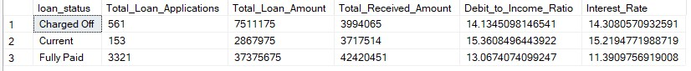 **Monthly Trends**

select month(issue\_date) as Month\_Number,datename(month,issue\_date) as Month\_Name,

count(id) as Total\_Laon\_Applications,

sum(loan\_amount) as Total\_Funded\_Amount,

sum(total\_payment) as Total\_Received\_Amount

from Bank\_Loan\_DB

group by datename(month,issue\_date),month(issue\_date)

order by month(issue\_date) ;

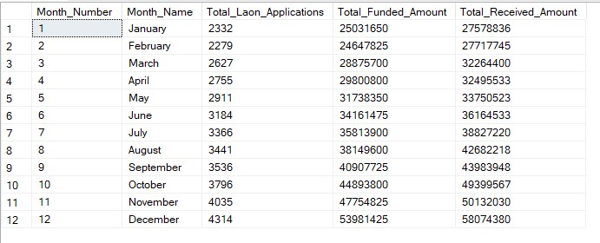

**Regional Analysis**

select address\_state as State,

count(id) as Total\_Laon\_Applications,

sum(loan\_amount) as Total\_Funded\_Amount,

sum(total\_payment) as Total\_Received\_Amount

from Bank\_Loan\_DB

group by address\_state

order by address\_state;

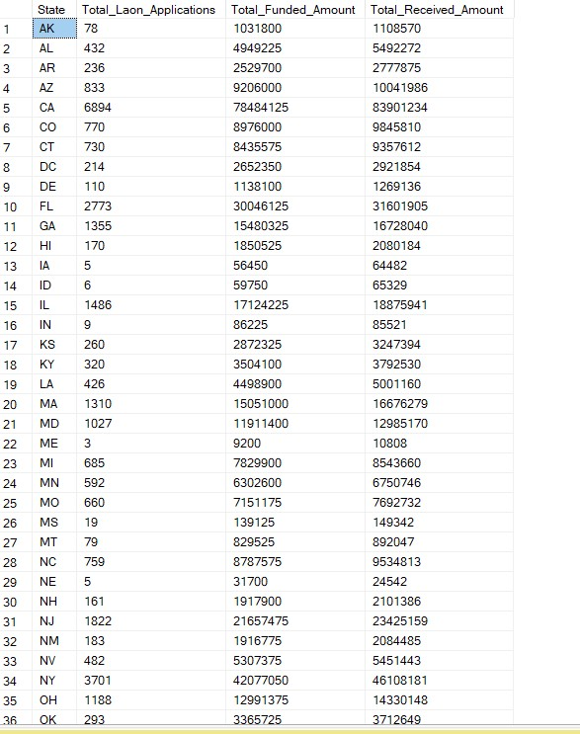

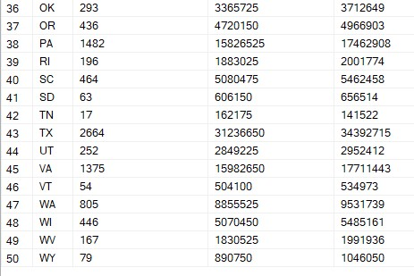

**Loan Term Analysis**

select term as Loan\_term,

count(id) as Total\_Laon\_Applications,

sum(loan\_amount) as Total\_Funded\_Amount,

sum(total\_payment) as Total\_Received\_Amount

from Bank\_Loan\_DB

group by term

order by term;

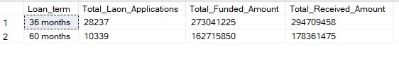

**Employee Length Analysis**

select emp\_length as State,

count(id) as Total\_Laon\_Applications,

sum(loan\_amount) as Total\_Funded\_Amount,

sum(total\_payment) as Total\_Received\_Amount

from Bank\_Loan\_DB

group by emp\_length

order by emp\_length;

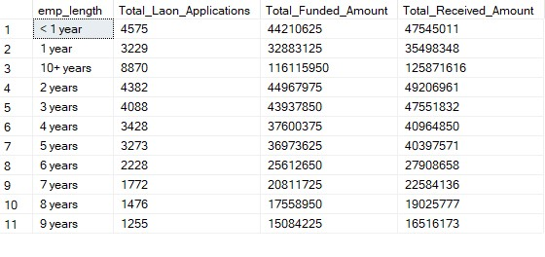

**Loan Purpose Breakdown**

select purpose as State,

count(id) as Total\_Laon\_Applications,

sum(loan\_amount) as Total\_Funded\_Amount,

sum(total\_payment) as Total\_Received\_Amount

from Bank\_Loan\_DB

group by purpose

order by purpose;

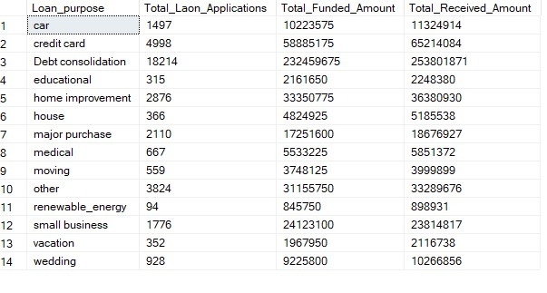

**Home Ownership Analysis**

select home\_ownership as home\_ownership,

count(id) as Total\_Laon\_Applications,

sum(loan\_amount) as Total\_Funded\_Amount,

sum(total\_payment) as Total\_Received\_Amount

from Bank\_Loan\_DB

group by home\_ownership

order by home\_ownership;

